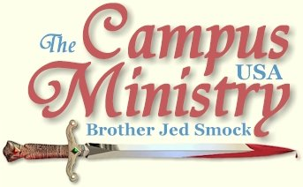
brojed@aol.com
brojed.org
573-999-0347
573-999-0347
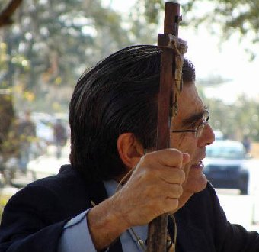

PREACHING CUT SHORT BY RAIN
University of Central Florida, January 10, 2011
With rain threatening we were hindered from gathering a crowd. At 1 PM Nick, whom I remembered from our visit before Christmas stopped to listen. He asked me what I thought about gun control. I responded that we have too much government regulation as it is. An atheist with Jewish parents criticized the Bible but the stories he brought up were confused. He claimed angels told someone in the Bible to offer up his daughter to a gang of rapists. He wanted to know if one could be good without Jesus. A girl said that she had just stopped to listen. During this time, two foreign students entered into an argument with Martha concerning war. After about thirty minutes a light rain drove the small group away; the precipitation soon turned into a downpour. Martha and I ran back to our car and we were soaked by the time we got there.
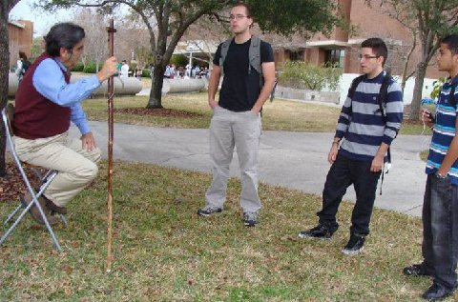
Martha had a discussion about war with the two on the right.
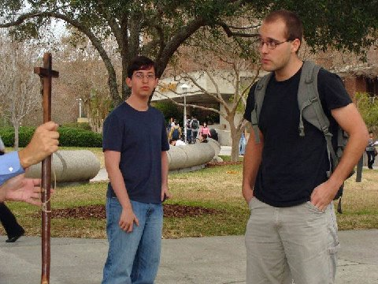
"Nick, (on right)the agnostic, whom I have mentioned in other reports and I see every day came up late in the afternoon, admitted that he was depressed and suicidal. "
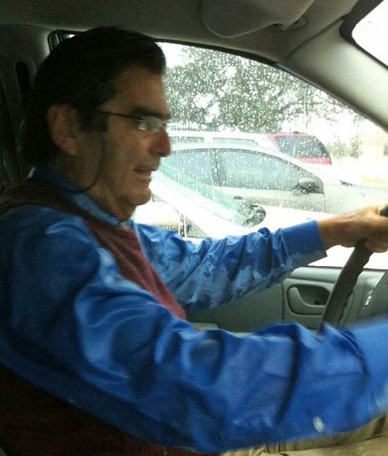
"Martha and I ran back to our car and we were soaked by the time we got there."
HELP FROM ONE WHO HEARD ME 30 YEARS AGO
University of Central Florida, January 11, 2011
Anne, who heard me at the University of Kentucky in the early 80’s and who was connected with the Maranatha Ministries of that era, came out with her daughter, Abby, 13 and her son Matthew who must have been 10 or 11. They live in Orlando and attend an Assembly of God.
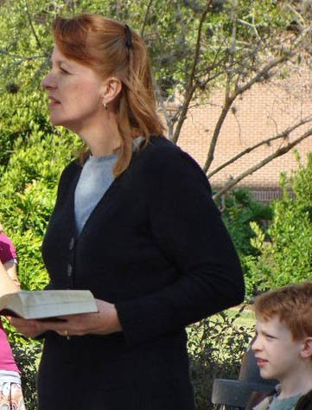
"Anne, with her Bible opened, rebuked the Baptist girl for her behavior, which led to her having a conversation with Anne."
I preached for about 30 minutes with the Christian family as my audience. Finally, several stopped and listened at a distance. Eventually, a fellow began to heckle me. Then Nicole came on the scene; I asked her about the hickey on her neck which she seemed rather proud of. A Baptist girl then chimed in who claimed to also have a hickey. I could not see her blood spot. She told me that she was the best girl in her church. Both of these girls were live wires and likeable and were good natured in taking my rebukes. The Baptist girl seemed to think that there was something virtuous about her relationship because she was “monogamous.” Historically, that term has been used in the context of marriage. Now it seems to include anyone intimate with only one person whether married or not.

"Then Nicole came on the scene; I asked her about the hickey on her neck which she seemed rather proud of. "
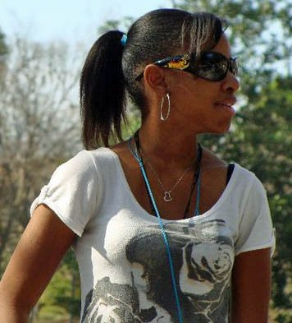
"A Baptist girl then chimed in who claimed to also have a hickey. .. She told me that she was the best girl in her church."
I called upon Martha about 3:45. She began taking questions from the students. Several said that it was difficult to argue with her because she was giving reasonable answers. Still they did not accept what she was saying. Alas, they just do not want to give up their sins.
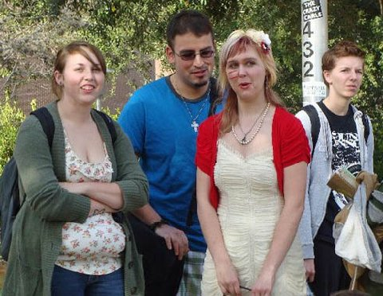
UCF Students respond to the preaching.
In the evening Nicole sent me a message on facebook, “Hi, I was the girl with the hickey at UCF today, and I had fun listening to you talk. How long will you be at UCF and are you always near the library?”
Anne, with her Bible opened, rebuked the Baptist girl for her behavior, which led to her having a conversation with Anne. Later the Baptist girl wanted me to show her in the Bible where it says, “It is good for a man not to touch a woman (1 Cor. 7).”
Several Christians attempted to correct me for preaching the law instead of grace. They were not hostile as sometimes the Christians become. I suspect that they were not hostile because they were truly saved. They were simply ignorant on the subject of Biblical evangelism; they did seem to have a passion for souls.
We preached until almost 5:30. In the evening I received the following encouraging email from Anne:
Dear Brother Jed,
My children and I had a meaningful time out at UCF with you.
After hearing you preach for a few minutes, my son, Matthew, said, “Now THAT’S real preaching!”
A student came up to me and asked me why I would bring my children out there to hear all the ugly things that were being said. I responded that I’ve been telling them that the world hates God and that by bringing them out there, they could see it for themselves.
Abby has something she would like to tell you:
Hello, Brother Jed! God bless you!
When Mom asked me what I thought of your preaching, I could only say one word: wow. We heard the “Baptist” girl, who was obviously not a Christian, and we also heard the lesbian girl—oh! The lesbian girl was saying disgusting things! I also heard something which really affected me. You had been talking about a couple who did not kiss outside of marriage (I had been paying attention to a conversation Mom was having with someone, so I did not hear the whole story), and I heard a girl in the crowd say “She’s missing out.” I wanted dearly to respond to her by saying that actually the girl in the crowd was missing out. Kissing is intended between a married couple of the opposite sexes, and it is then when it is the most wonderful. If kissing is taken part in any time before, it is a letdown compared to what it is meant for. It was an experience I’ll never forget, and one day perhaps I’ll take my kids to see you.
Sincerely,
Abigail
Thank you for making a difference in our lives, Brother Jed. We will be continuing our school work here at home this week but I hope we can see you again the next time you are in town. Many blessings to you.
Anne
Because Abigail is unusually mature for her age, she reminded me of Mattie, the 14 year old girl in the movie, True Grit.
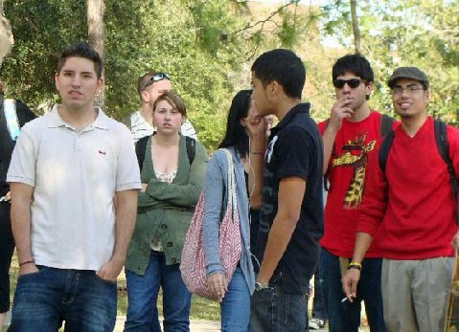
Faith cometh by hearing and hearing by the Word of God...
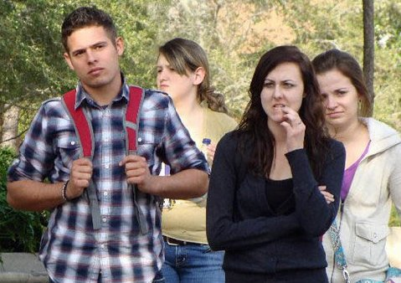
And how shall they hear without a preacher...and how shall they preach except they be sent..?
A CROWD OF FOUR
University of Central Florida, January 12, 2011
The temperature dropped considerably today into the mid-fifties, still with sunshine. There were other groups in the free speech area. One was a Reformed Christian group giving out hot chocolate and animal crackers. Another Christian organization set up a basketball goal and was promoting a dunking contest. Then there were the Crescendudes, an all male cappella, “where music and goofy college guys collide.” They were sort of a glee club and they put on a good performance. So I waited until they were done singing, which was about 1:30.
The largest crowd I drew was a group of four, at least two of which were Christians. One was a Calvinist, who had read my book and done some open air preaching. The Calvinist objected to what he referred to as my crude jesting. He asked if I thought a Calvinist could be a Christian. I affirmed that I did but I thought that the doctrine of predestination was not an incentive to evangelism and the teaching of an inherited sin nature encouraged sin because it made it impossible to obey God. Despite their theology, I acknowledge that many Calvinists had a zeal for souls and had pure hearts. But it was despite the decrees and doctrines, not because of them. We also discussed open theism and the gifts of the spirit.
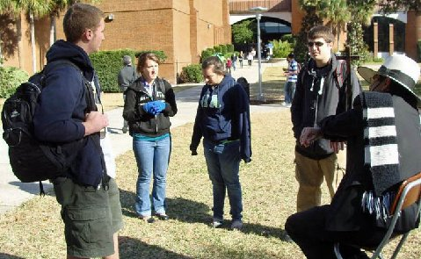
"We also discussed open theism and the gifts of the spirit. "
Alex, an exuberant Catholic girl, who was educated in Catholic schools admitted that she had not been to confession since she was confirmed. But she listened for about 15 minutes. She thanked me for inspiring her. As she left, the Christians with the basketball goal cornered her for several more minutes. I had a few other good conversations. And I did a lot of preaching as people passed. I supposed that the weather was too cold for these Floridians to stop and listen. We decided to call it a day at 3:30 PM. Anne and her family from yesterday are having Martha and me over for dinner tonight.
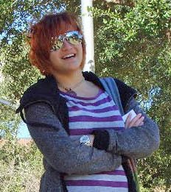
"She thanked me for inspiring her. "
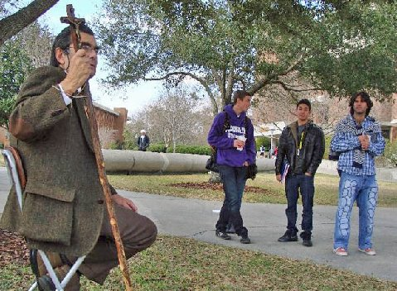
UCF Listener
MY MARK ON HER SOUL
University of Central Florida, January 13, 2011
The weather remained cold and sunny today. I delayed going to campus until 12:45 to give time for the weather to warm. I gave Martha the day off to go to Disney World with her sister, Charlotte.
As I was waiting for the class break, Nicolle, the girl with the hickey, whom I had reproved on Tuesday came up in a friendly manner asking, “Why aren’t you yelling at people today?”
She told me that her parents were criminals who dealt in drugs and other unlawful activity. He grandparents were Baptists. She had some catholic upbringing. She claimed to have tried Christianity at one time but she never “felt anything.” I explained that Christianity is a matter of truth not feeling although if she would truly forsake her sin she would sense a clear conscience. She claimed to have a clear conscience. One can sin so much that her conscience is by and large inactive. Meanwhile, there was a class break, but I made the decision to continue to give Nicole my attention. She needed it and I hoped that others would see us talking and I could build an audience without preaching.
Soon others approached me including a middle age man who had fond memories of Cindy and me preaching at the University of Florida before we were married when Cindy still wore her large floppy hats and floor length skirts. He told the story how one day Cindy pulled a big hat pin out and brandished it before a threatening crowd. The story may be apocrypha, but it adds to the legend. He wanted me to tell the account of Cindy’s conversion. A Christian in a sleeveless undershirt entered into the conversation. I mildly reproved him for his inappropriate attire. Of course, Nicole liked his sleeveless undershirt. The young man did seem to have a good spirit about him and gave a fine witness to Nicole, even succeeding in getting her to promise she would at least give Christianity a try by reading the Bible. Meanwhile, two Christian girls came on the scene. One of whom also gave an effective witness except for saying that we cannot help but sin. The other girl ended up sitting on the grass with Nicole and conversing with her for a long time. I have hope for Nicole; she has a sweet personality and seems opened.
I had a long talk with a Christian whose father was Iranian and mother a Christian. He said he had had a discussion with his father last night but had difficulty dealing with his father’s question as to why God would create a race of men who he knew would become evil. That was a wonderful opportunity for me to expound upon open theism. The young man was receptive to this explanation.
Meanwhile, I dialogued through another class break without “yelling,” because I continued to have people come and go with serious questions. Of course, there were the usual concerns about my methodology and emphasis on sin and God’s law. But my questioners were not antagonistic and I sensed that I may have even made some progress.
Nick, the agnostic, whom I have mentioned in other reports and I see every day came up late in the afternoon, admitted that he was depressed and suicidal. He is a soft spoken young man. He had many questions concerning Hell. I pressed him on the suicide issue informing him in no uncertain terms that he should never consider that again. He said he had not attempted it since three years ago. He showed me the scar where he had slit his wrist. When we parted, he remarked, “Who knows, I may become a Christian someday.”
Once again, this is just a sampling of good conversations I had. By 3 PM, I decided that I would not preach. Sometimes it is good to have a change of pace and be more personal with students. I considered it a profitable day. I never had more than ten listening at once. Sometimes there were several conversations going around me concerning things of the Spirit. I did not see Nicole leave but she must have been around for at least two hours. As the boy had left the hickey on her stiff neck the other night, I am confident that I left my mark on her soul and softened her neck this afternoon, which I do not believe will disappear as the hickey had by today. With the sun setting the temperature began to drop and the people thinned out. I left campus at 4:15. I considered it a profitable day.
MY HEAVENLY FATHER WATCHES OVER ME
University of Central Florida, January 14, 2011
Although I did not get crowd the first break, Justin, who has been out there every day and almost daily challenged my approach, again had some questions. This time he finally agreed there was a place for confrontational evangelism.
At the next break I gathered an audience, which ranged from 12-20 for most of the afternoon. Roy, who is a Jew, objected to the idea that God was watching him all the time. I responded that I liked the idea since I consider that God was watching out for me.
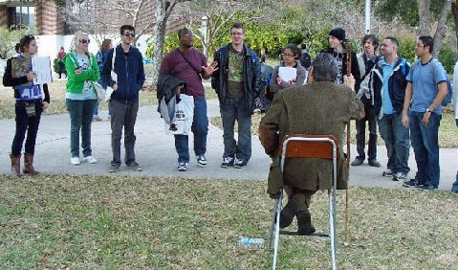
There was little talk about the sexual issues or other moral issues today. The conversation revolved around why I believe in God.
By 3:00 I had several Christians interrupt to answer the students’ questions which can be helpful but often they do not understand how to hold the attention of everyone. As a result the crowd will break up into smaller groups, which can be advantageous. But then it is difficult to bring the crowd together again. By 3:00 there were three groups talking. I had a few come up and ask me questions. At 3:45 as we were leaving Tony thanked me for coming, “You have provoked a lot of conversations,” he said. I explained that was one of our objectives to stir the pot. “Well, you have stirred the pot,” he replied. This was progress coming from Tony because he is one who has listened day after day but earlier in the week had challenged me on my approach.

"There was little talk about the sexual issues or other moral issues today. The conversation revolved around why I believe in God. "
Thank you for your faithful prayers and support. Please continue to pray for us. You may donate to CMUSA using PayPal by going to our web site brojed.org or by mailing your check to our home address: CMUSA 2402 Longview Dr. Columbia, MO 65203. All gifts are tax deductible. Thank you for your generosity.
Bro. Jed and Martha Marie's Schedule
The following is my tentative winter/spring schedule. I encourage Christians to arrange to meet me on campus for a day or even week or so. It will be a life changing experience if you have never been on an open-air campus outreach. If would like to arrange for me to speak in your local church, I would be happy to oblige. Or maybe some of you would introduce my ministry to your friends in a home setting. If you would like to provide hospitality while we are in your area either call or email me. Also, since some of this schedule is subject to change, if you would like me to come to your campus instead of what I have planned please let me know. I may be persuaded.
January 18-21 Louisiana State University
January 24-25 Sam Houston State
January 26-28 Texas A&M
January 31 University of Texas
February 1-3 Texas State University, San Marcos
February 7-9 New Mexico State
February 10-11, 14-18 University of Arizona
February 21-25 Arizona State University
February 28- March 1 UCLA
March 2 Long Beach State
March 3 UCLA
March 4 UC San Diego
March 7 San Diego State
March 8-9 San Marcos State
March 10 San Diego State
March 11 UC San Diego
March 14-15 Fresno State
March 16 Long Beach State
March 17-18 San Marcos State
March 21-25 Texas Tech
March 28-29 University of Oklahoma
March 30 University of Central Oklahoma
March 31-April 1 University of Oklahoma
April 4-29 Missouri campuses
May 2-June 3 to be announced

